Installation Manual
OMMCOM NEWS
VERSION 1.0

Luminous Infoways Pvt. Ltd.
Address: N6-373, IRC Village,
Bhubaneswar - 751 015, Odisha, India
Phone: +91 674 2360573, +91 674 6451236
Fax: 91 674 2360724
Web: www.luminousinfoways.com

Revision History

Version (x.y) | Date of Revision | Description of Change | Reason for Change | Affected Sections | Approved By
Version 1.0 | 22 Feb 2015 | NA | NA | NA | Project Manager

Approval History

Version (x.y) | Prepared By | Reviewed By/Date | Approved By/Date
Version 1.0 | System Analyst | Project Manager/22 Feb 2015 | Project Manager/22 Feb 2015

Table of Contents

1 Application Installation and Configuration 4
1.1 Verifying Environment Setup 4
1.2 Application Installation 4
1.3 Application Configuration 4
1.4 Installing Patches 4
1.5 Administering the Application 4
1.6 Starting up and Shutting down 4
1.7 Troubleshooting tips 4
2 Hardware Configuration 5
2.1 Machines Setup and Configuration 5
2.2 Connectivity Configuration 5
2.3 Verifying the Hardware Setup 5
2.4 Troubleshooting 5
3 Product Configuration 5
3.1 Setting Configuration Parameters 5
3.2 Modifying Scripts 5
3.3 Others 5
4 Application and Environment Tuning 5
4.1 Application Tuning 6
4.2 Operating System Tuning 6
4.3 Database Tuning 6

Application Installation and Configuration

Verifying Environment Setup

Hosting Environment is verified by checking weather IIS server is installed or not, port 80 is working or not, check w3 Service is running if not start this process. Check in browser weather IIS is properly install or not . Check Sqlserver all services are running or stopped if stopped then restart the service and make the service start type automatically.
Media streaming server
Web server – apache 2.X

Application Installation

Application Setup is created that can be deployed in Ubuntu 14.X hosting server , setup can guide next step with install proper place . User need not to install any software to run this package. Only browser is required to run this software. It can be run any platform it is completely platform independent. Or to run this software just copy all the files in a drive then create a virtual directory and setup path in server .

Application Configuration

For application configuration the following points to check.
1) all the framework must be installed in server system
2) Server must be 64 bit for better productivity
3) A Separate application pool should be maintained to run application if application fail other application should not be hampered
4. Landing page should be set it would be (Default.aspx, Default.asp, Index.htm etc)
5) Database connectionstring must be correctly assign in IIS or user web.config file so that it can connect to database all the time.
6) All the Global error pages must be set for Custom Error, In case of Application Crash, File not found, Server Error specific page will show.

Installing Patches

In web based application Separate version will update in IIS server with taking backup older version.

Administering the Application
For Administering the application we have to connect remote desktop for any administrative process .

Starting up and Shutting down
In web based application run in dedicated server that runs 24x7 in order to top and start the server there is a option Manager Server Start ad stop IIS Service. When application shutdown user cannot access the application online or offline.

Troubleshooting tips
Not applicable

Hardware Configuration

for Hardware configuration in Server Side. Minimum Requirement
Dedicated Server with window OS 2012 64 bit
Sqlserver 64 bit 2012 Version
RAM 24GB
Separater Database Server with 8gb RAM that will run dedicate 24x7 hour

Machines Setup and Configuration
This section should capture details of machines to be setup including routers and switches. Also, details of which version of OS to be installed etc. should be captured

Connectivity Configuration

Not applicable

Verifying the Hardware Setup
Detailed steps of how to verify hardware setup should be provided. This could include checking details of IP addresses, primary domain controllers, user ids and groups, network domains etc.

Troubleshooting
Not applicable

Product Configuration
This section details the products that need to be configured for successfully deploying the application. Please note that the process of installing the product could also be covered here in case the product installation manual is not available or detailed enough.
The following sections need to be completed for every product being installed like web server, database, LDAP, application servers, firewalls etc.

Setting Configuration Parameters

IN this application all the configuration is maintained in a single file named web.config
where we can provide Database connectionstring, appsetting, version, username and password, customer error handler, culture handler,application running mode etc.

Modifying Scripts
Not Applicable

Others

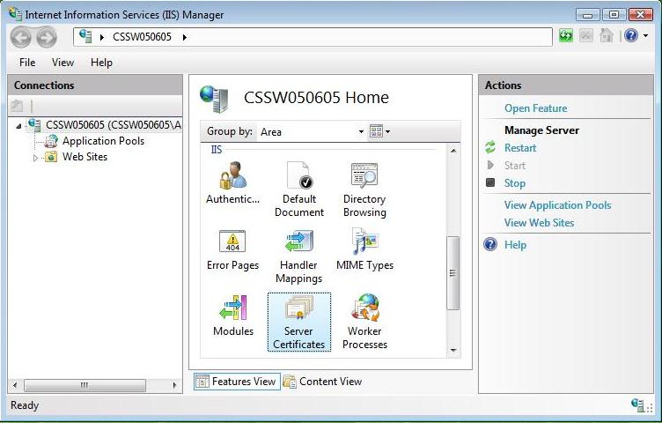

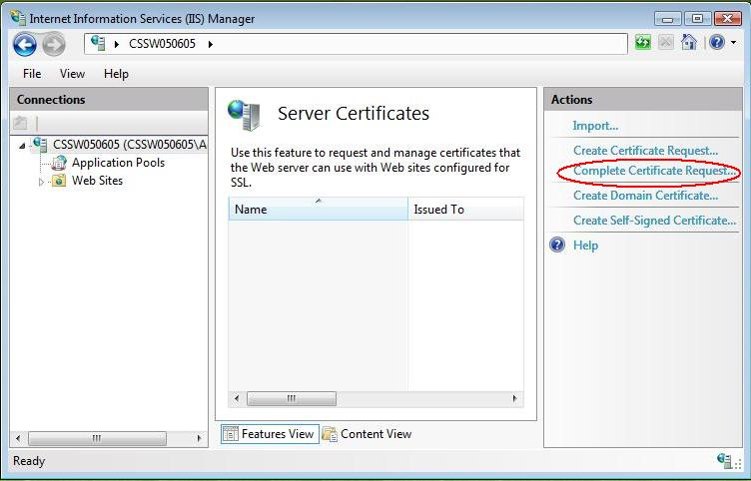

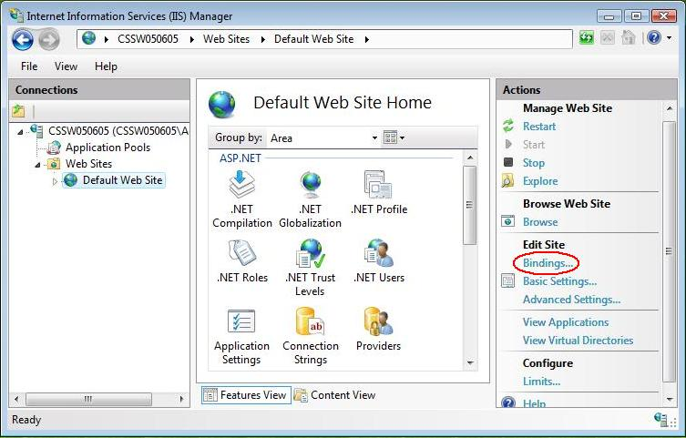

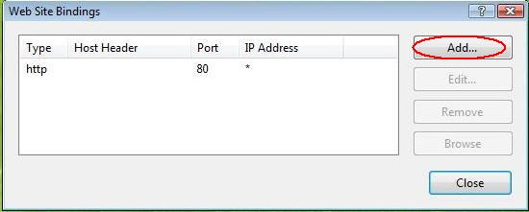

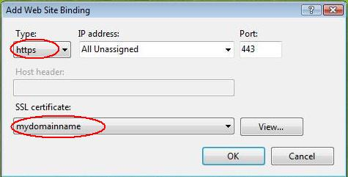

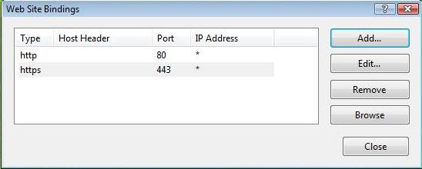

Application and Environment Tuning

User Load
Transaction rate measured on one CPU
Increase in performance from additional CPUs
Increase in performance from additional servers
If the system must cope with failures, size the system to meet performance requirements assuming that one or more application server instances are non functional
Excess capacity for unexpected peaks

Application Tuning
Avoding Response.Redirect
Separate Connection Pool
Proper Threading
Use StringBuilder to concatenate strings
Client-side script for validation
Include Return Statements within the Function/Method
Avoid Unnecessary Indirection
Choose correct collections object
Store your content by using caching
Avoid making frequent calls across processes
Make JavaScript and CSS External

Operating System Tuning

Monitoring usage of system resources.
Selecting tools to measure system performance
Diagnosing problems from the results of measurement
Tuning the operating system and application parameters
Upgrading the hardware resources of the system
Planning for optimal performance

Database Tuning
This section should cover details of database settings like guidelines for creating indexes, fill factors etc.

Following factors are needed for database tuning
Index Scans
Table Scans
TV Scans (Table Valued Scan)
Indexes Scan or Seek with high I/O or CPU cost (particularly more those larger than 1%)
Key Lookup ( Bookmark lookup) and RID (Record Identifier lookup)

Database Compression

